Review
SuiteCommerce Standard Project.
- Each item will have a custom field (Custitem_maximum_number_of_units_per_client) which will indicate how much units can a customer purchase from this item.
There is one only maximum per item. So for example, item A can have a maximum of 4 for each customer, item B can have a maximum of 10 for each customer.
- Customer can not purchase more than that quantity until a time lapse pases. This time lapse will be a field in the configuration record, for example it can be 48hs.
So if customer purchases item A 4 times, if he tries to buy one more time, he will need to wait this time lapse.
- If customer tries to purchase and time lapse has not passed, an error message will be shown, which is a field in the configuration record.
This needs to be shown on PDP, PLP, quick order and reorder history.

Steps:
1. Get custom field that has limit number for the item, get time lapse from configuration record and error message.
2. Call my service to run a search and get transactions from 0 to 48hs for this client in particular with a saved search, then sum up transactions for the item desired and if it’s over the limit, cancel the add to cart.
3. If success, nothing, If error, show an error message: can’t be a pop up since for SC it does not work properly on quick order and reorder, perhaps just skip over these cases (issue)

I have come to think the following possible solutions to this issue:
- On beforeAddToCart event:
- Use a Pop up to show the error message: before the item will be added to the cart we will be stopped by the promise, over there we will need to know in which view we are at the moment (when did the add to cart call was done). We get this info by SCA function: container.getLayout().getCurrentView() but this project is SC.
if you are in any of this views: 'ProductDetails.QuickView.View', 'ProductDetails.Full.View', 'Cart.Confirmation.View' you need to only reject the promise with a message as parameter.
If you are not in any of those views, if you reject the promise with a parameter as message, it does not show the pop up, and you need to show the manual created pop up, and reject the promise without a message, otherwise it screws up.
Since we can not know in which view we are, the promise.reject(error_message) for reorder history or any other view different than 'ProductDetails.QuickView.View', 'ProductDetails.Full.View', 'Cart.Confirmation.View' does not show the error pop up (I have tested it in other client before).
Do you have any other ideas how can I fix this to have the pop up show up for all?

- Use other area of quick order or any other possible area, + previous option with pop up for PDP. Not possible on SC?
- Use any area or data-view on layout to set an error message whenever conditions happen. Preferably not use this one
- Skip error message on PLP, Quick Order and reorder history. Better not use this one also
There was other possibility that arised which was to do the validation before the order was placed:
- On place order:
- Do a script that runs before submitting the sales order (user event?) and discards the sales order if any of the products was over purchased, and then mark somehow and return the info of the products which have failed
How would you guys tackle the error message thing? Return error, easy.

Only 45hs on the job. Which could be a good estimation for this?

Probar en mi página de testing
- Cada item tiene su cantidad limite en el item record
- El time frame es customizable, viene de configuration record pero es para todos los ítems el mismo.
- Un mensaje de error configurable, un único.

Scriptable Cart to validate on each line + UE to validate that nothing has changed at the moment the order is placed (time can have passed)

No puede ser mayor a:
- Historial de transacciones
- Cantidad en el cart del item
Transaction line field que source en scriptable cart.
Llamar un suitelet, en el validate line
Por performance.

El client script quizás anda mal por performance.

Hacer el user event, que sabemos que anda, y luego ver el client quizás tiene problemas de performance, ver si sobran horas.

Lo del client es una proof of concept.

Esto en 1.0

Final solution:
User Event.

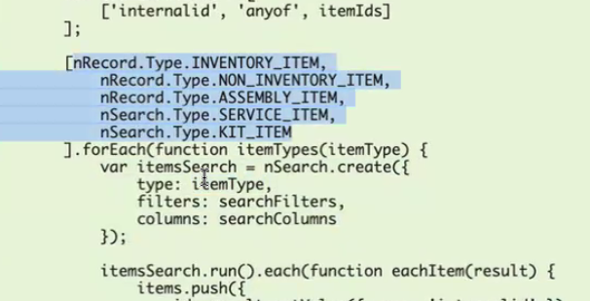
Hacerlo para item solo, que sea genérico, anda bien. Reemplazar type con el string ‘item’
// buscarlo como 'item' solo
[nRecord.Type.INVENTORY_ITEM,
nRecord.Type.NON_INVENTORY_ITEM,
nRecord.Type.ASSEMBLY_ITEM,
nSearch.Type.SERVICE_ITEM,
nSearch.Type.KIT_ITEM
].forEach(function itemTypes(itemType) {

